Performance Evaluation

Sarah Boctor

Wednesday, May 13, 2015

Funds used in creating the portfolio
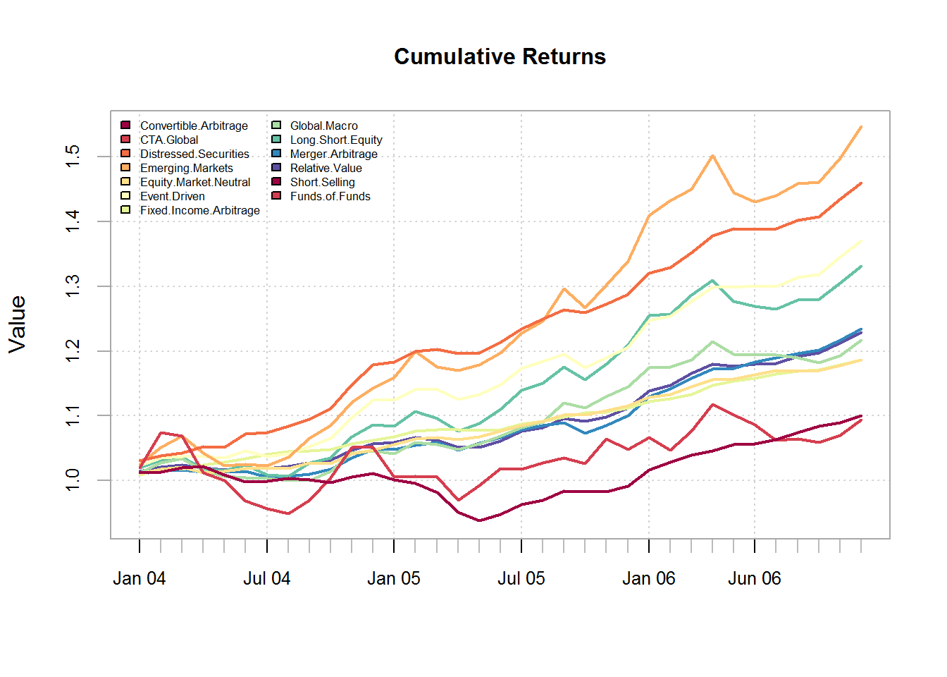

Create Optimal Portfolio
- I assume quarterly rebalancing, and will add a weight limit for most funds of 30% long or short, and for 2 risky funds a lower limit of 5% long/short . Also the portfolio will have a position limit of 10 maximum positive positions, and 2 negative positions.
- The Portfolio will satisfy a maximum percent ES(Expected Shortfall) objective of 0.5 and an overall monthly mean return of 0.001
## **************************************************
## PortfolioAnalytics Optimization with Rebalancing
## **************************************************
##
## Call:
## optimize.portfolio.rebalancing(R = managers1, portfolio = port,
## optimize_method = "random", search_size = 5000, trace = TRUE,
## rebalance_on = "quarters", training_period = 10)
##
## Number of rebalancing dates: 9
## First rebalance date:
## [1] "2004-12-31 EST"
## Last rebalance date:
## [1] "2006-12-31 EST"
##
## Annualized Portfolio Rebalancing Return:
## [1] 0.09531
##
## Annualized Portfolio Standard Deviation:
## [1] 0.03521
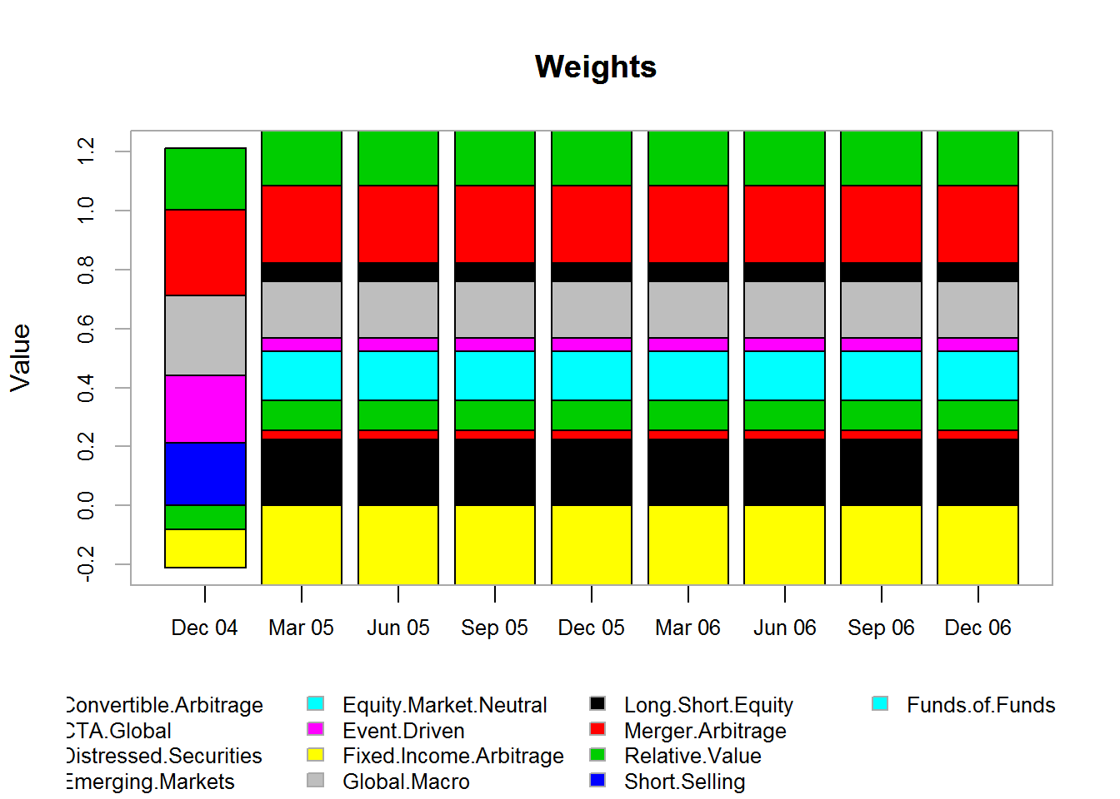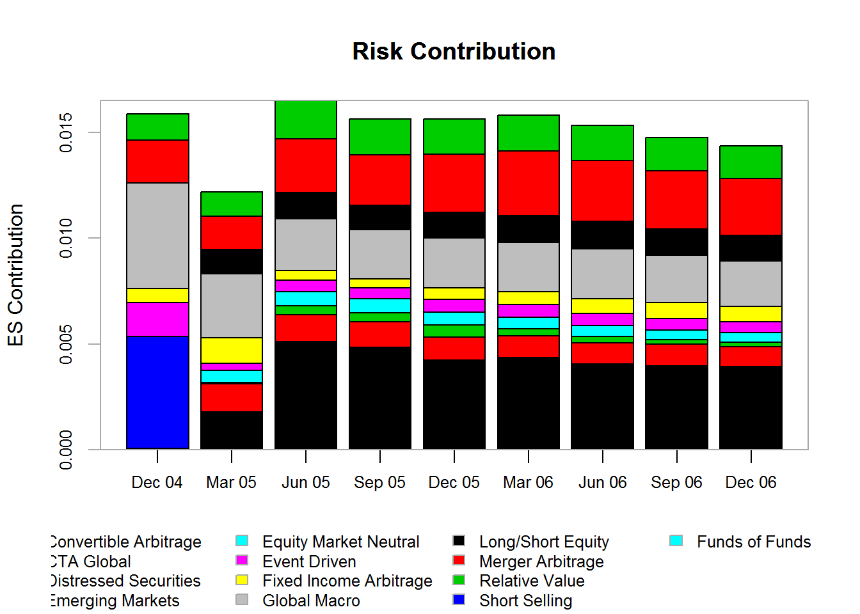

Create an Efficient Frontier and Chart the Weights
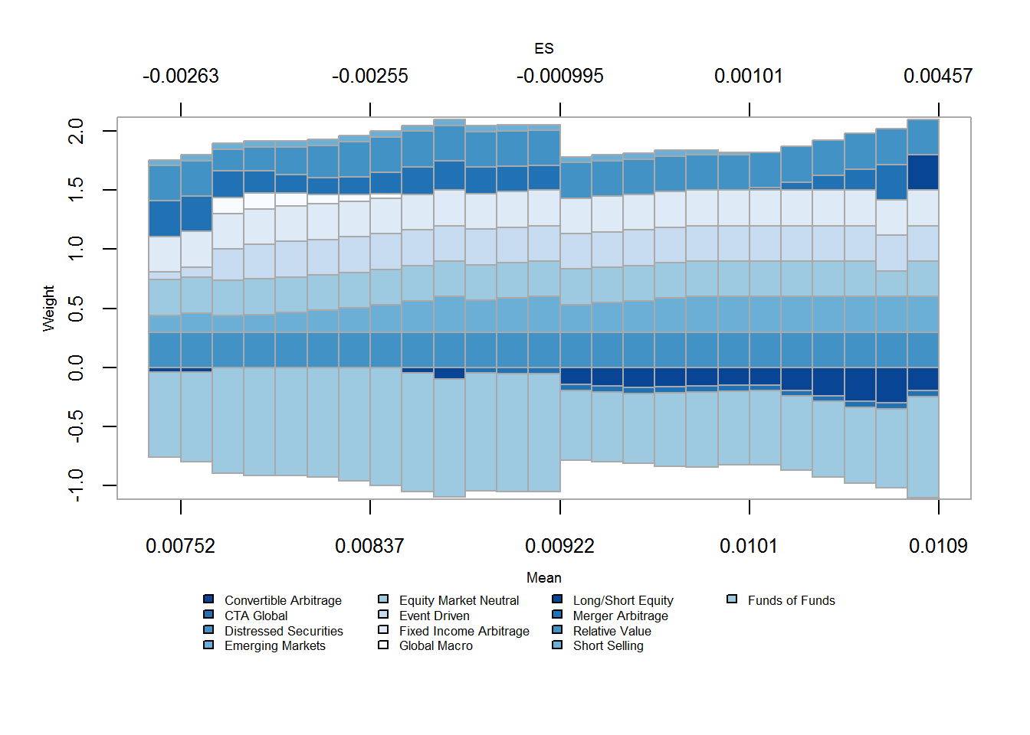

Annualized Returns
Portfolio SP500.TR
## Annualized Return 0.068 0.104
## Annualized Std Dev 0.043 0.069
## Annualized Sharpe (Rf=1.08%) 1.306 1.339

Calendar Returns
## Jan Feb Mar Apr May Jun Jul Aug Sep Oct Nov Dec Portfolio
## 2004 1.0 0.7 -1.7 -1.0 -0.4 -0.7 -0.1 1.0 0.4 2.2 0.9 -0.2 2.0
## 2005 1.2 -1.1 -2.0 0.5 1.5 1.9 0.8 2.2 -1.4 1.5 1.8 3.4 10.7
## 2006 0.6 1.6 1.6 -1.6 -0.1 0.1 0.6 0.2 1.3 1.8 1.6 0.0 7.8
## SP500.TR
## 2004 10.9
## 2005 4.9
## 2006 15.8

Trailing Periods Return
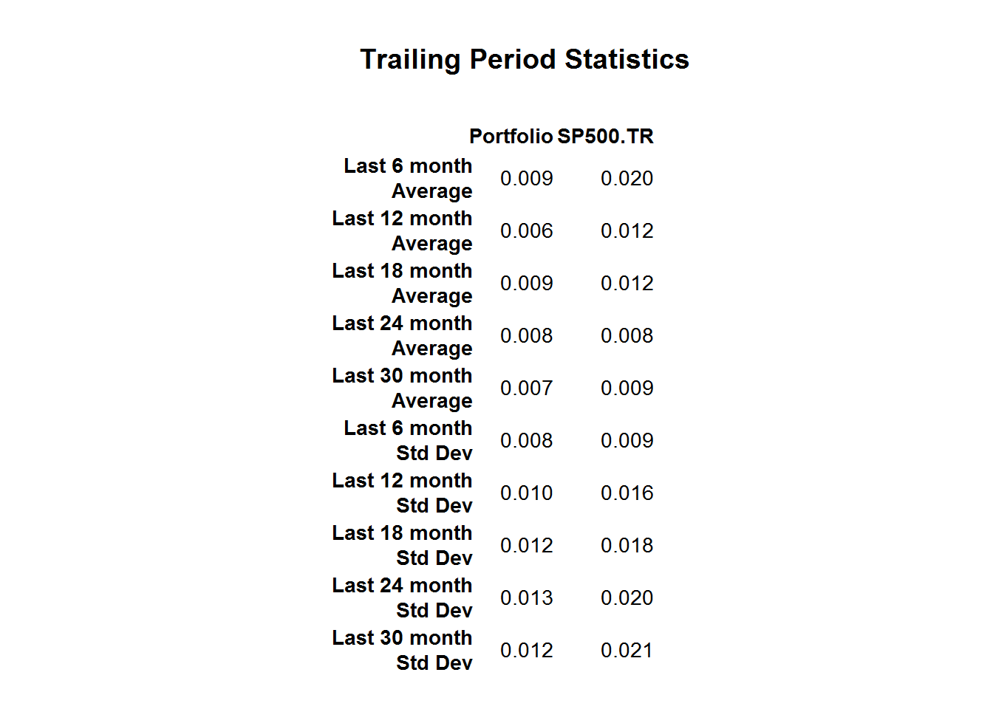

Rolling Performance
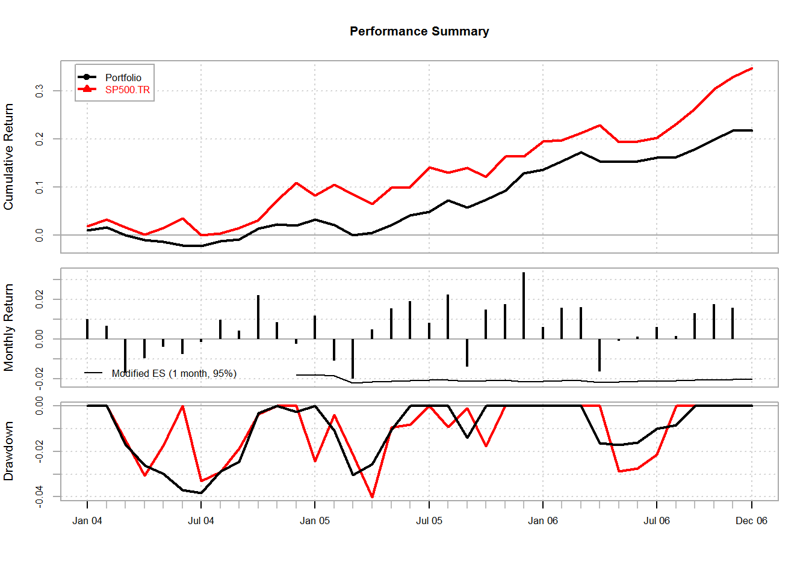

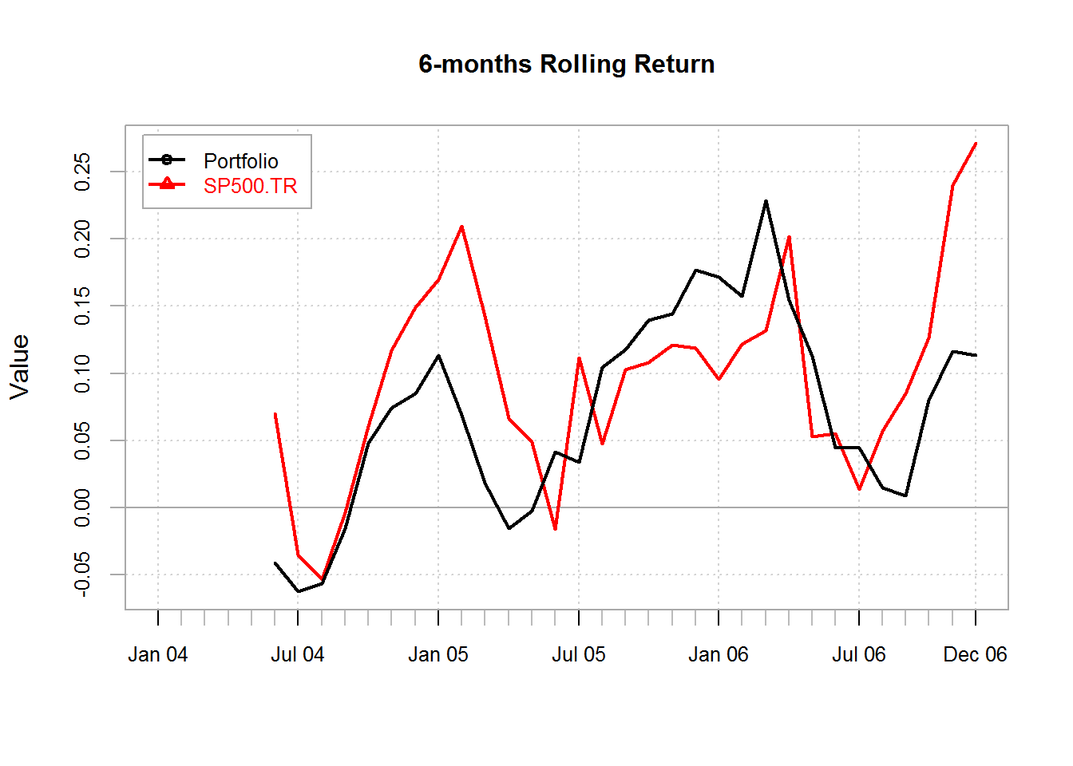

Relative Performance
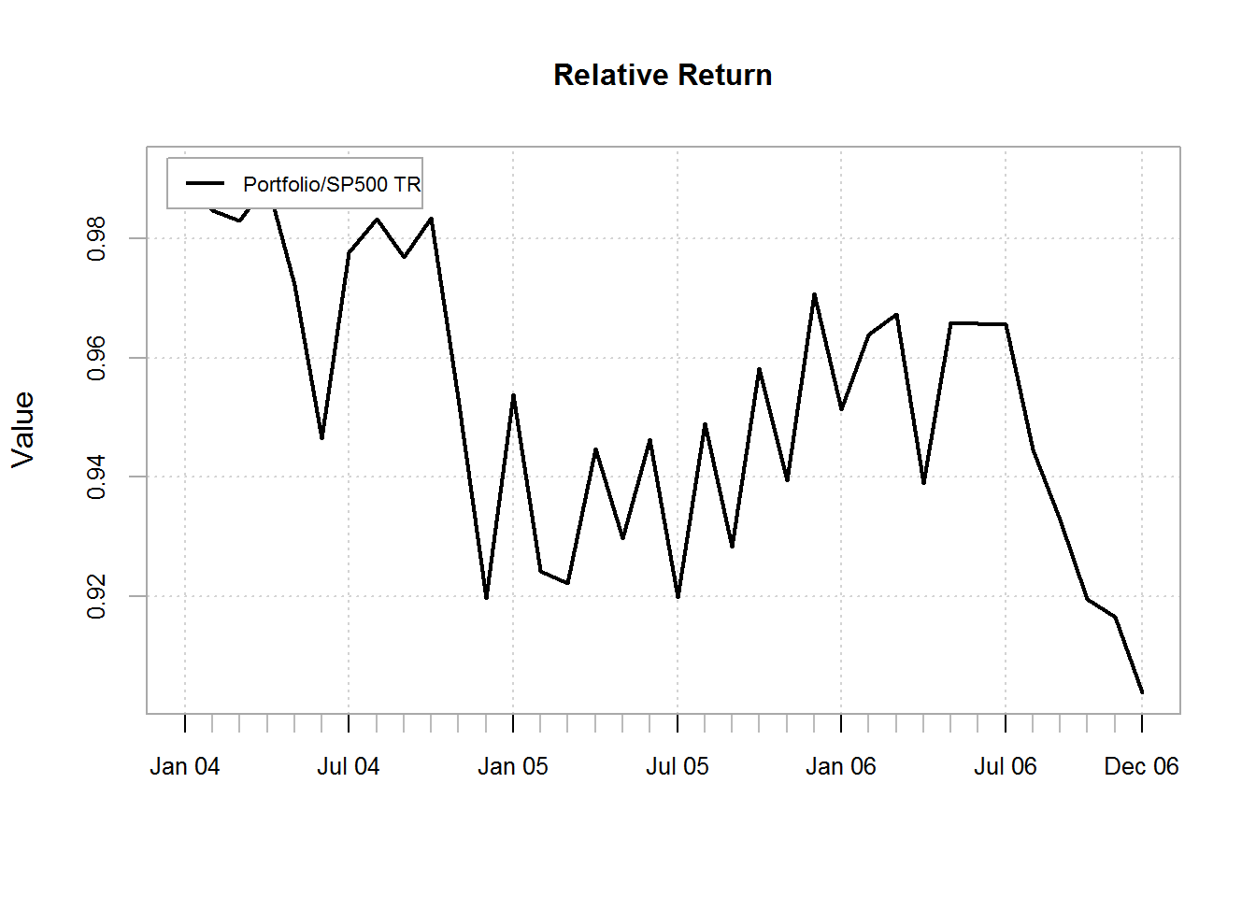

Outperformance and Underperformance
## Up Capture Down Capture Up Number Down Number
## Portfolio to SP500 TR 0.4 -0.03 0.74 0.56
## Up Percent Down Percent
## Portfolio to SP500 TR 0.22 0.78
## period_lengths Portfolio SP500 TR total periods
## 1 1 13 23 36
## 2 3 12 22 34
## 3 6 11 20 31
## 4 9 12 16 28
## 5 12 7 18 25
## 6 18 6 13 19
## 7 36 0 1 1
## prob_Portfolio_outperformance prob_SP500 TR_outperformance
## 1 0.3611 0.6389
## 2 0.3529 0.6471
## 3 0.3548 0.6452
## 4 0.4286 0.5714
## 5 0.2800 0.7200
## 6 0.3158 0.6842
## 7 0.0000 1.0000

Upside and Downside Frequency
## Portfolio SP500.TR
## Upside Frequency (MAR = 0.008%) 0.4722 0.5833
## Downside Frequency (MAR = 0.008%) 0.5278 0.4167
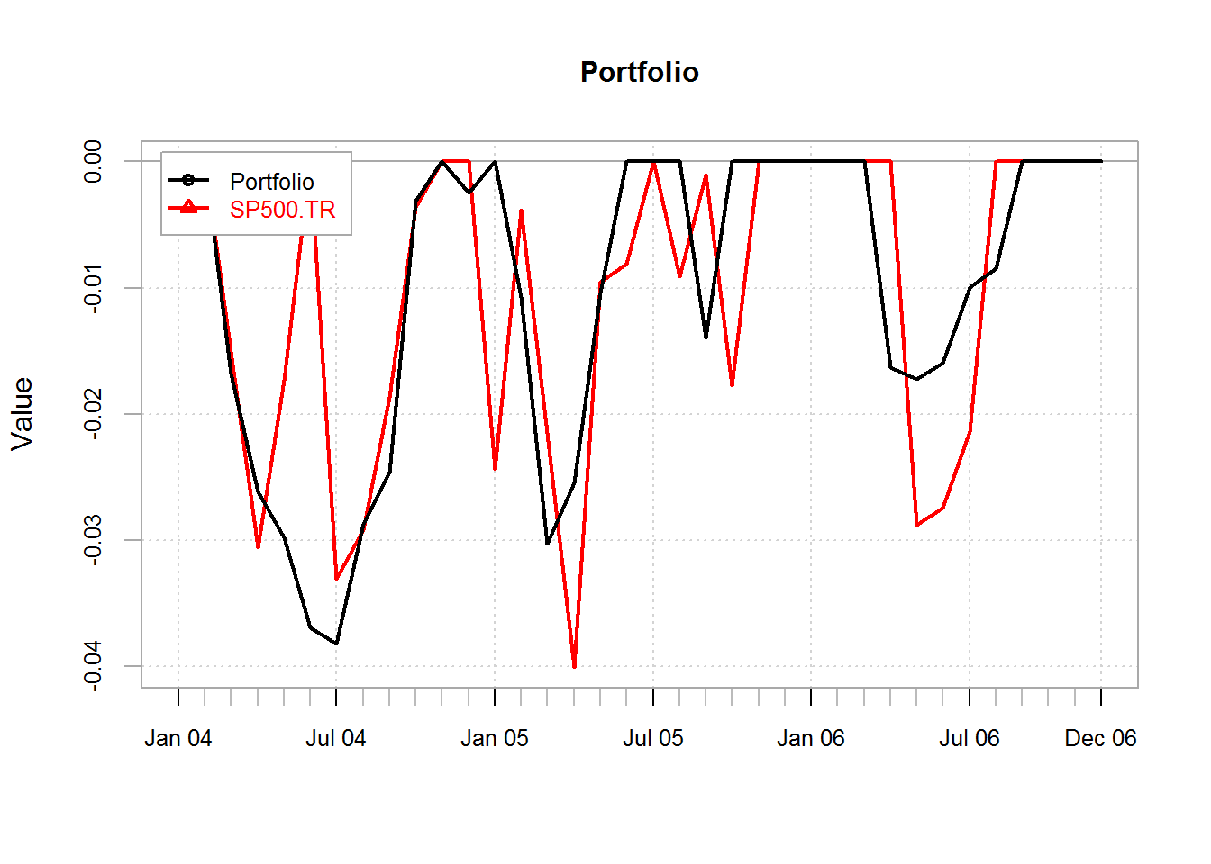

Risk Analysis
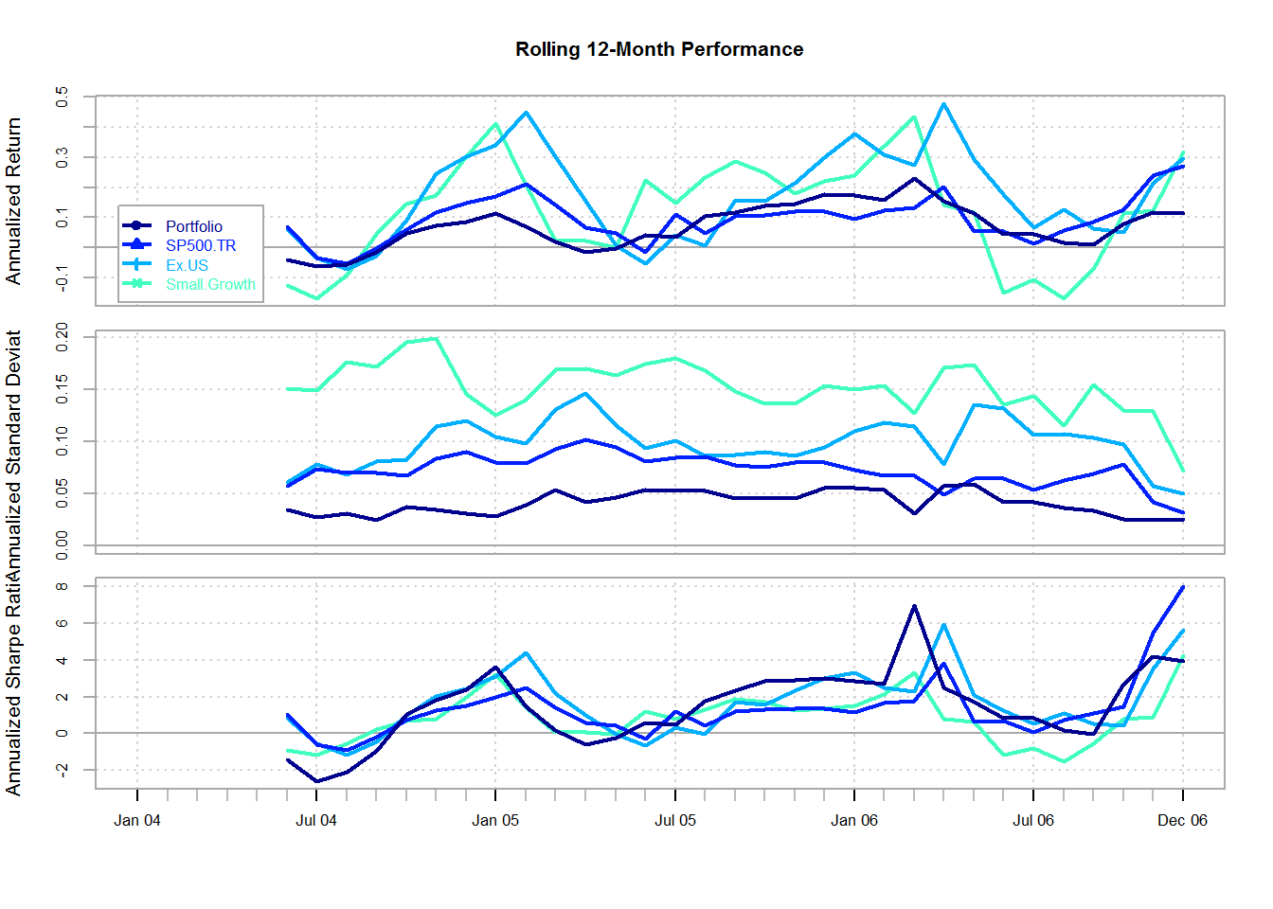
 | Portfolio | SP500.TR
## Semi Deviation | 0.009 | 0.015
## Gain Deviation | 0.008 | 0.012
## Loss Deviation | 0.007 | 0.007
## Downside Deviation (MAR=10.2%) | 0.011 | 0.015
## Downside Deviation (Rf=3.03%) | 0.007 | 0.011
## Downside Deviation (0%) | 0.006 | 0.011
## Maximum Drawdown | 0.038 | 0.040
## Historical VaR (95%) | -0.016 | -0.025
## Historical ES (95%) | -0.018 | -0.031
## Modified VaR (95%) | -0.016 | -0.026
## Modified ES (95%) | -0.020 | -0.032
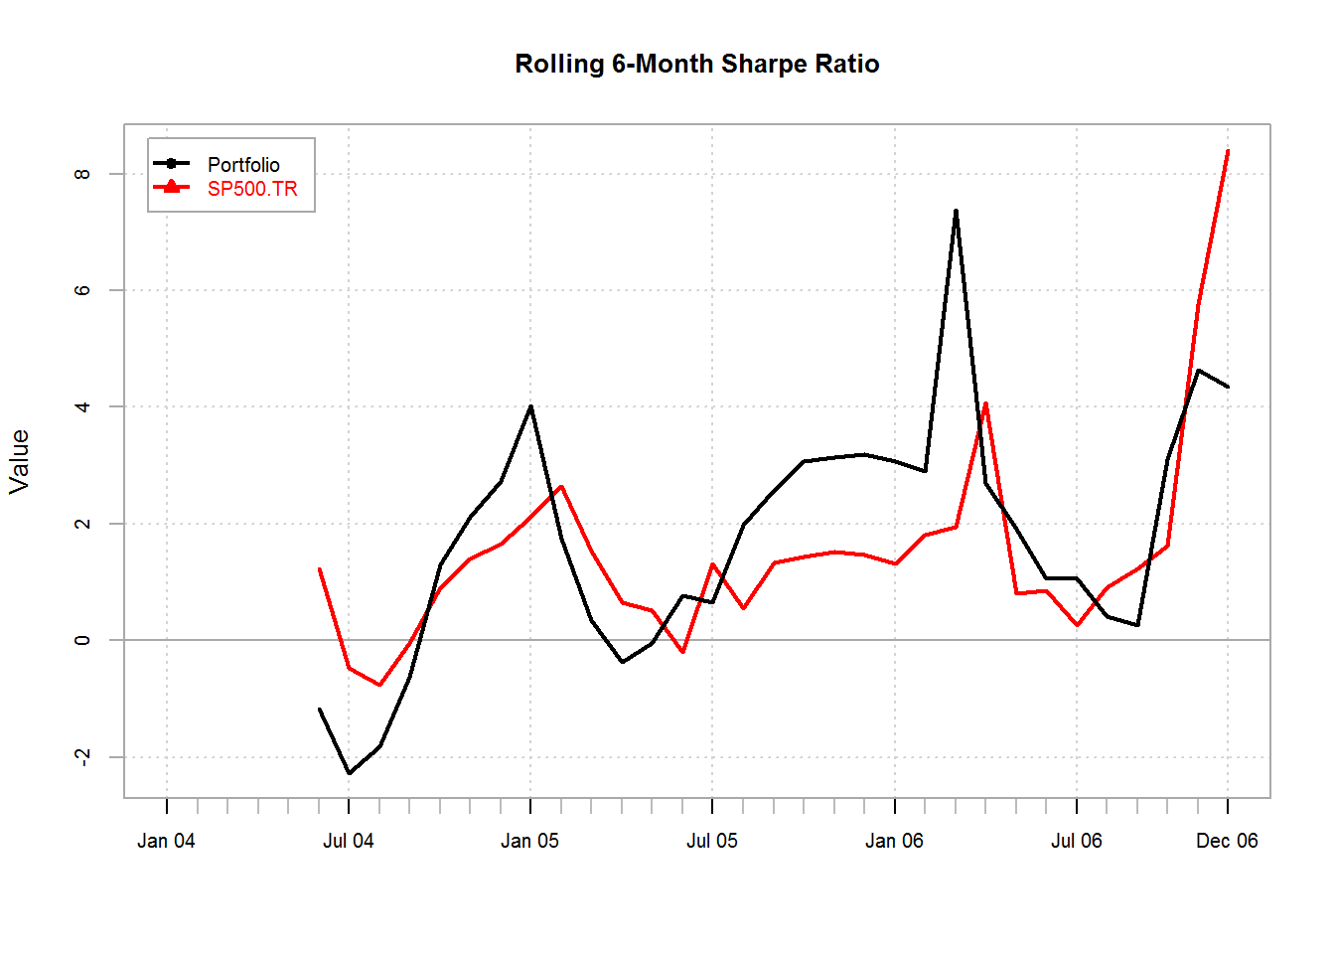
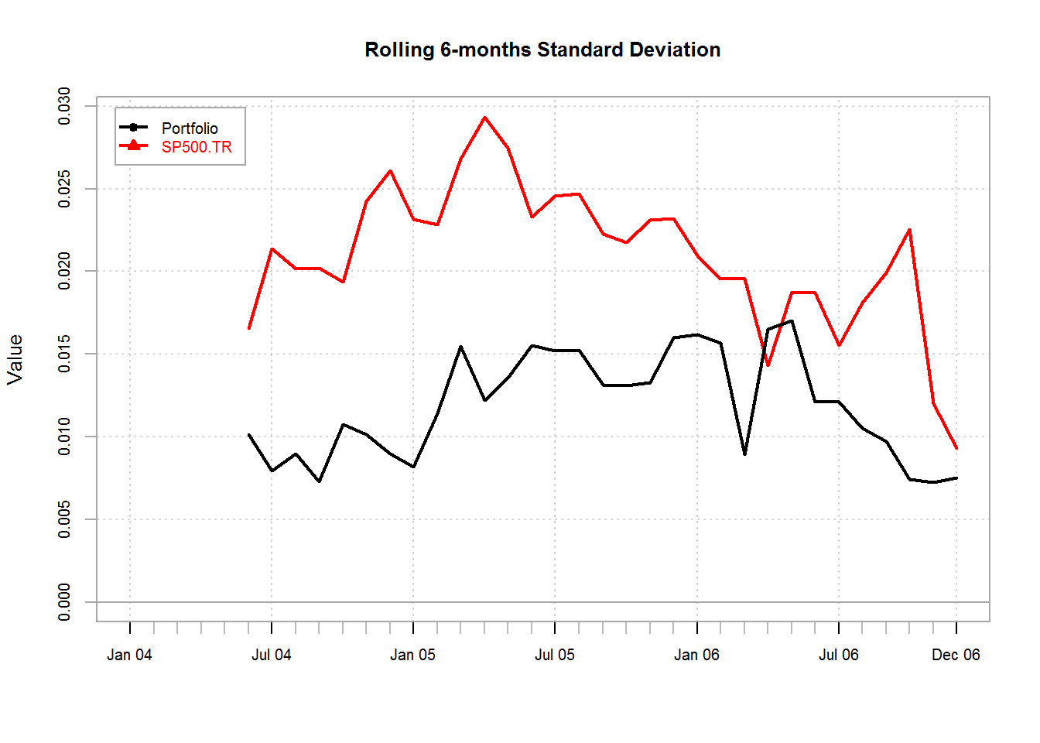
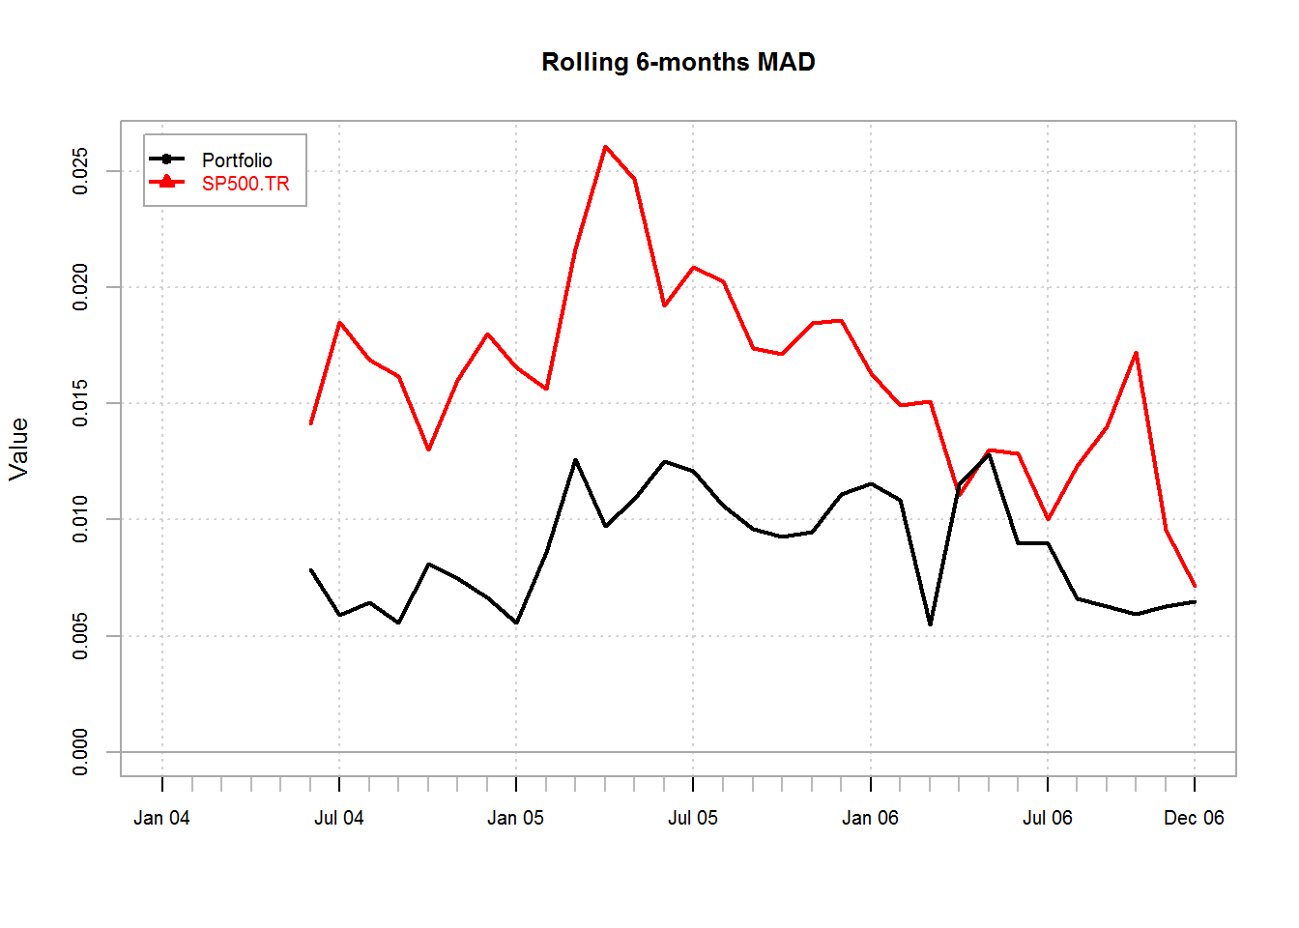
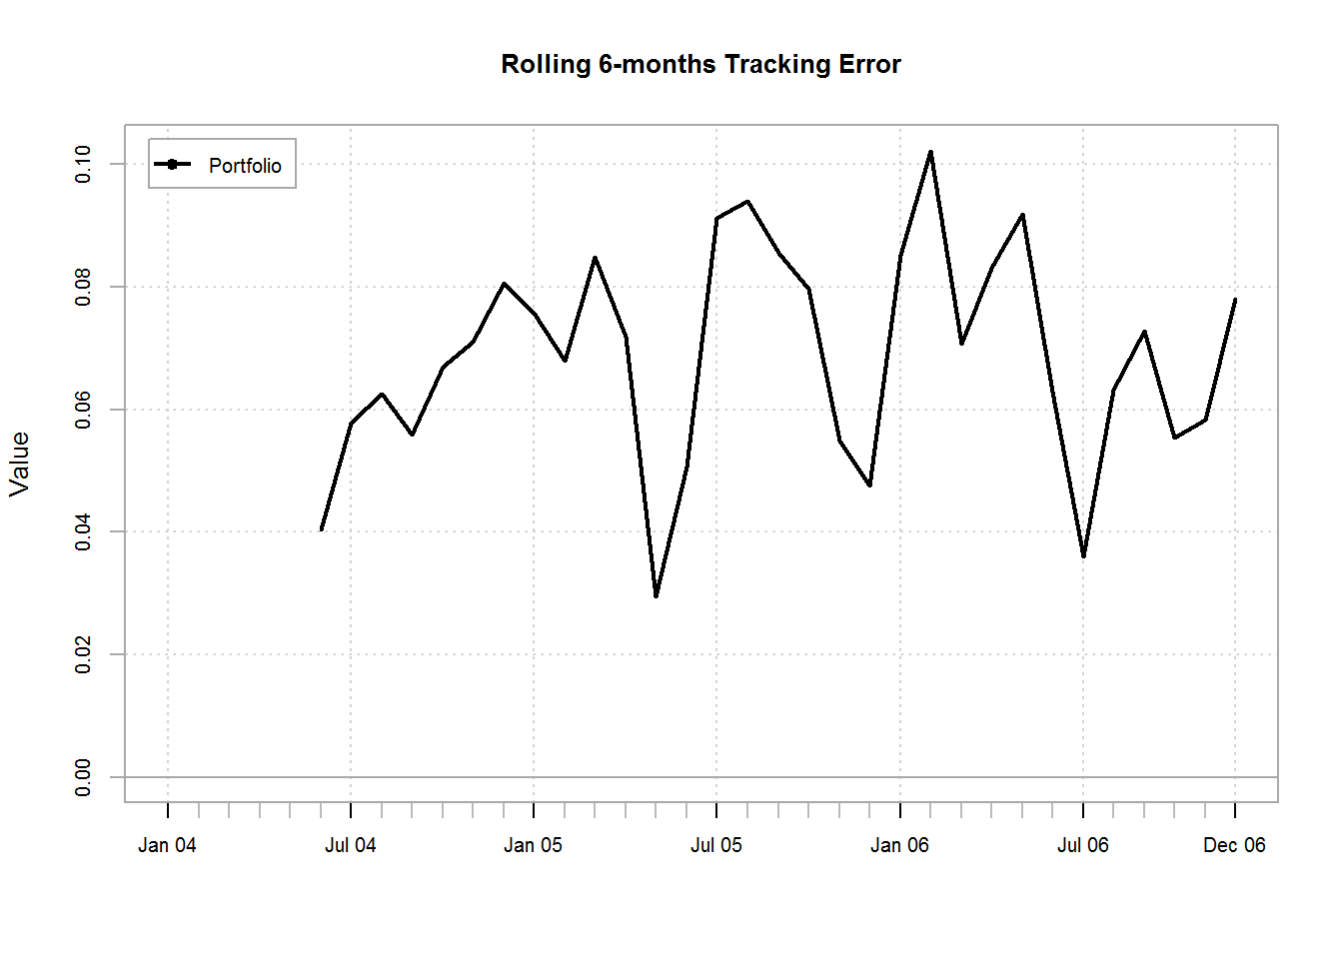
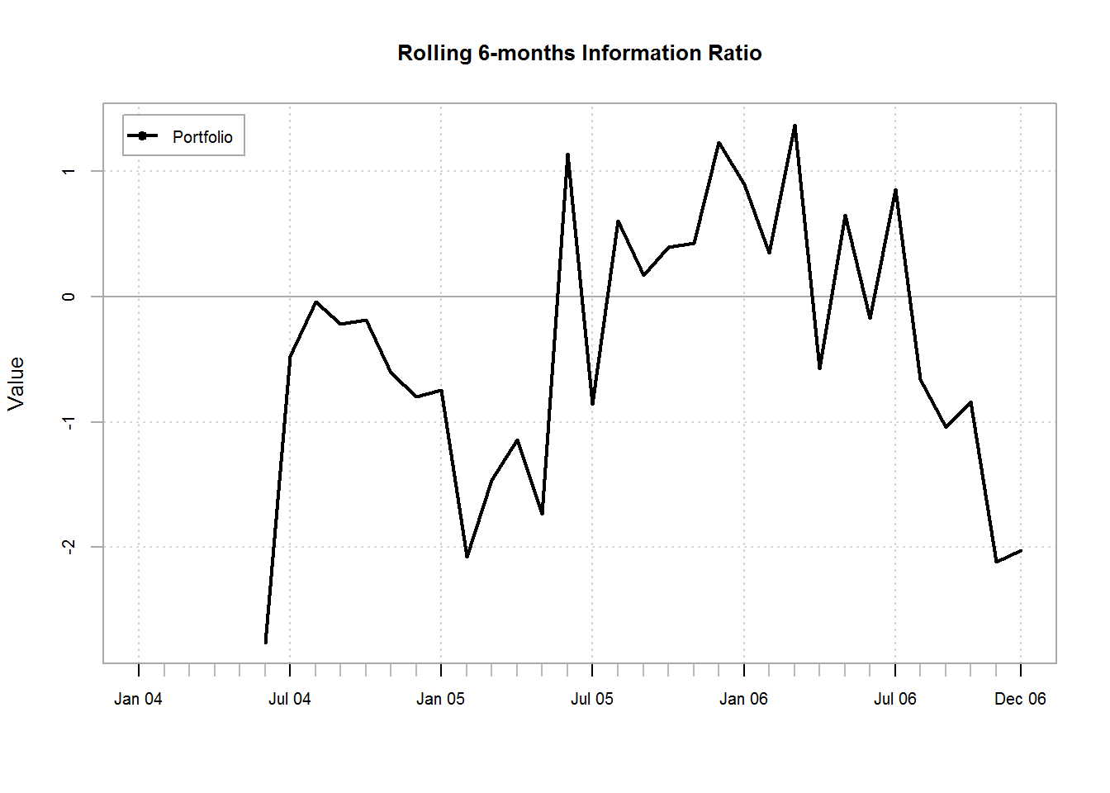

Style Analysis
- Performing Sharpe Style Analysis on the Hypothetical Composite Portfolio by first conducting the style analysis on the component funds
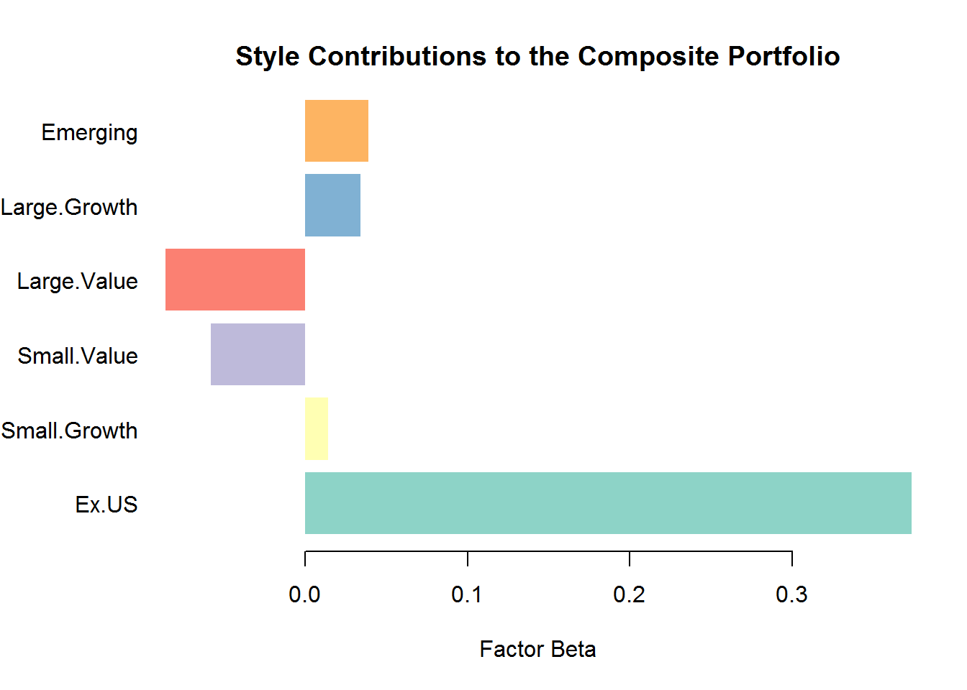

Factor Risk Composition

Portfolio Tail Risk Measures

Normal VaR
VaR(HP, p=0.95, method="gaussian")
## Portfolio
## VaR -0.01466
VaR(HP, p=0.99, method="gaussian")
## Portfolio
## VaR -0.02304

Factor-Based Normal VaR
normalVaR(mu.fm.p, sd.fm.p, tail.prob=0.05)
## [,1]
## [1,] -0.01457
normalVaR(mu.fm.p, sd.fm.p, tail.prob=0.01)
## [,1]
## [1,] -0.02246

Cornish-Fisher (modified VaR)
VaR(HP, p=0.95, method="modified")
## Portfolio
## VaR -0.0155
VaR(HP, p=0.99, method="modified")
## Portfolio
## VaR -0.02348

Historical VaR
VaR(HP, p=0.95, method="historical")
## Portfolio
## VaR -0.01643
VaR(HP, p=0.99, method="historical")
## Portfolio
## VaR -0.01874

Normal ES
ES(HP, p=0.95, method="gaussian")
## Portfolio
## ES -0.0198
ES(HP, p=0.99, method="gaussian")
## Portfolio
## ES -0.02721

Factor-Based Normal ES
normalES(mu.fm.p, sd.fm.p, tail.prob=0.05)
## [,1]
## [1,] -0.01941
normalES(mu.fm.p, sd.fm.p, tail.prob=0.01)
## [,1]
## [1,] -0.02639

Modified ES
ES(HP, p=0.95, method="modified")
## Portfolio
## ES -0.02002
ES(HP, p=0.99, method="modified")
## Portfolio
## ES -0.02709

Historical ES
ES(HP, p=0.95, method="historical")
## Portfolio
## ES -0.0183
ES(HP, p=0.99, method="historical")
## Portfolio
## ES -0.01977

Portfolio Risk Decomposition:
1- Analyzing Risk Factors Contribution to the Risk of the Composite Portfolio
- in this case, the risk factors I used are the different investment styles. These can be easily replaced with macroeconomic factors, or industry fundamentals, etc..

Risk Factor Contribution to Standard Deviation
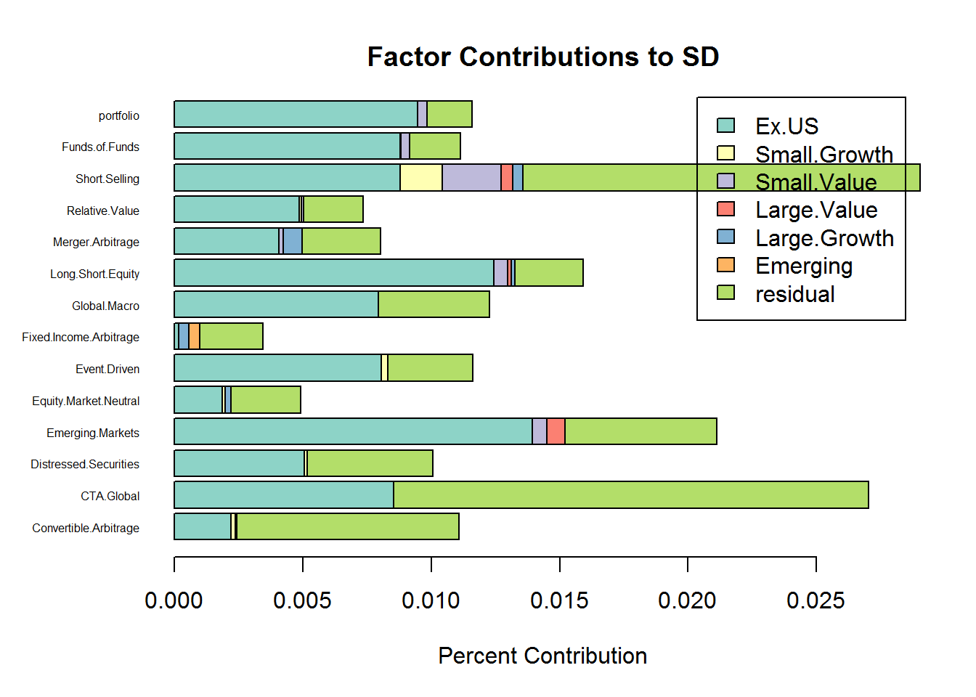
- Analyzing Fund Contribution to the Risk of the Composite Portfolio
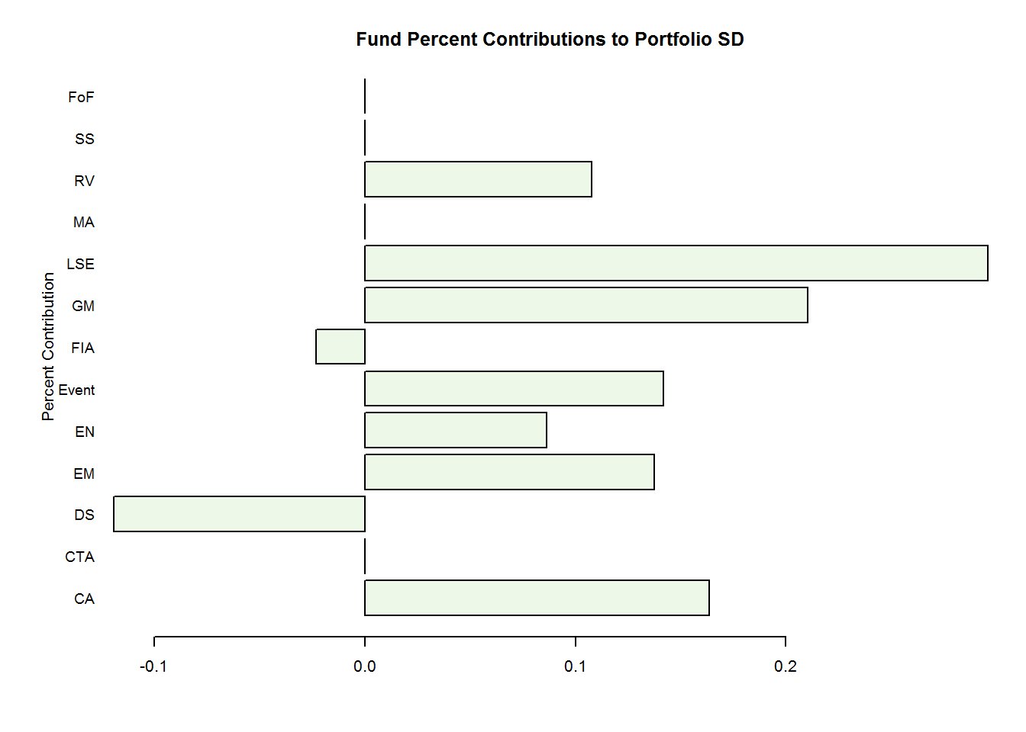
- Factor Model Monte Carlo
- Bootstrapping the individual funds returns, and recalculating the risk contributions of the different styles to the funds, and in return to the composite portfolio, a total of 5000 samples new data sets were produced, each having the same size as the original data.
